**CT404/CT336: Graphics & Image Processing**

Assignment 2: Image Processing & Analysis

Due Date: **Wednesday, Nov 13, 23:59 pm**

**Instructions:**

* This assignment consists of two tasks where each task involves several steps.
* You have been provided with an accompanying image file for each task.
* You will submit your assignment as a ***mini*** report.
* You will run the step(s) and document the resulting images and the values you select (if there are any to be selected in that step) in this mini report, as instructed.
* Since this is a mini report, no detailed explanation is required at each step.
* For a quick start, you are encouraged to look at the OpenCV code provided as ‘Lab Resources Part 1’. But you can use any image processing library to get through the steps.

***Be analytical and have fun!*** 😊

**Task 1: A Morphological image processing pipeline for medical images** [15 points]

The figure below shows a digital histopathology image of a skin biopsy where white globules (some of which are indicated by yellow arrows) depict fat cells and constitute **regions of interest** for this task. The rest of non-globular white areas (some of which are indicated by red arrows) are other structures in the tissue which are not relevant and will be treated as **noise** to be filtered. In a professional setting, such a mark-up is usually provided by trained pathologist to the image analysis experts. The overall goal of this task is to detect fat globules and calculate the following ratio (usually used for monitoring of disease progression):

***Tip:*** For this example, the total number of detected whole fat globules should be around 34.

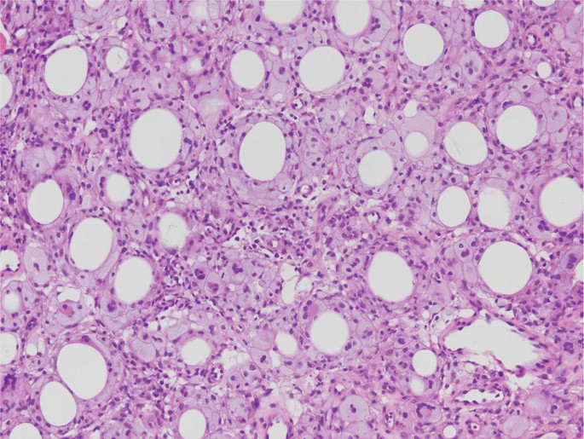

**Legend:**

Yellow: Some examples of white globules of fat to be detected

Red: Some examples of the white tissue structure considered as noise

Blue: Some examples of *partially* visible globules considered as noise

**1.1:** **Conversion to a single channel image** [2 points]**:** The given image file can be read as a 3 channel RGB image. The first step is to convert it to a one channel image. Either you can convert the given RGB to a grayscale image or you can use one of the RGB channels directly as a grayscale image. The important point is to have a better contrast. (For clarification on this, refer to the image below which was included in your Lecture 4).

 Image Source: Color Dependence Analysis in a CNN-Based Computer-Aided Diagnosis System for Middle and External Ear Diseases - Scientific Figure on ResearchGate. Available from: https://www.researchgate.net/figure/Matrix-representation-of-a-digital-image-upper-row-from-left-to-right-image-in-the_fig2_359806413 [accessed 11 Sept 2024]

Remember, since the biopsy image has the predominant colour hues of pink-purple, using one of the RGB channels might be better.

Mention in the report your selected image (grayscale or one of the RGB channels) and include the image in the grayscale.

**1.2: Image Enhancement** [2 points]**:** Now try histogram transformation techniques (histogram equalisation or histogram stretching on this image) on the grayscale image. Select the one which gives better contrast between fat globules and the background.

Mention the selected technique and include the resulting image in your report.

**1.3: Thresholding** [1.5 points]**:** Now that you have a grayscale image with better contrast, you need to threshold it with a suitable value to change it to binary/Black & White/BW image where the white regions (‘1’) will represent lighter regions in the biopsy. Remember that normal image processing pipelines also involve image smoothing before thresholding but for this assignment we skip that step. You can try several threshold values and choose the one that gives you the best results in your opinion.

Mention the value in the report and include the resulting BW image.

**1.4: Noise Removal** [2 points]**:** The threshold might have resulted in some ‘white’ noisy dotted spots which do not belong to fat globules or other white tissue structures. You can use image eroding and/or opening, opening with appropriate structural element of disk shape and size to get rid of these spots. Remember, this operation will also affect the fat globules to be analysed. Hence, during this operation, you might not to alter the original area of fat globules too much.

Mention which operation and structural element you have selected to use in your report and include the resulting image.

**1.5: Extraction of Binary Regions of Interest/connected components** [1.5 points]**:** At this step, use the neighbourhood and binary ‘connected components’ discussed during lecture to change your thresholded white binary regions into different connected components. This step will allow you to calculate different region properties of each region to filter fat globules from other thresholded structures.

**Tip:** You can use [*connectedComponents()*](https://docs.opencv.org/3.4/d3/dc0/group__imgproc__shape.html#gac2718a64ade63475425558aa669a943a) in OpenCV to calculate these properties.

**1.6: Filtering of Fat Globules** [5 points]**:** Now that you have obtained connected components for white regions, the next step is to filter out regions which are not globule-like and do not potentially represent fat. You can use the properties of area, compactness, eccentricity to filter out non-globule regions. Find suitable properties and values to perform filtering. You can do it in several steps as per your choice and analysis.

**Tip:** You can use the [‘Contour Features’](https://docs.opencv.org/4.x/dd/d49/tutorial_py_contour_features.html) in OpenCV to calculate region properties.

Mention the region properties and their values you have selected for filtering and include the resulting images after filtering regions based on each property in your report. Also include the total number of fat globules you have left at this point in your report.

**1.7: Calculation of the Fat Area** [1 point]**:** As final step, use the area (in pixels) of the remaining fat globules to calculate the percentage of fat using the equation above. Include this percentage in your report.

***Congratulations! You have implemented your first medical image analysis pipeline completely.***

****************************************************************************************

**Task 2: Filtering of Images in Spatial & Frequency Domains** (10 points)

Many of the online image ‘beautifying’ or ‘retouching’ tools/apps involve some sort of image blurring to make skin look smoother with fewer skin marks caused by, for example, wrinkles, pimples, moles, scars, etc. In this task you will implement your own version of image blurring to make facial skin look smoother. Although, in original apps/tools, a mechanism is incorporated to apply blurring only to facial skin and not to other facial features (such as eyes, mouth corners, lips, nostrils, hair), this task involves blurring the complete facial. The accompanying image file is of high resolution so facial wrinkles and smoothing will be quite visible. The figure below shows the facial image of a celebrity where wrinkles are visible on the skin. You will be running this task on this image (provided as a separate file).

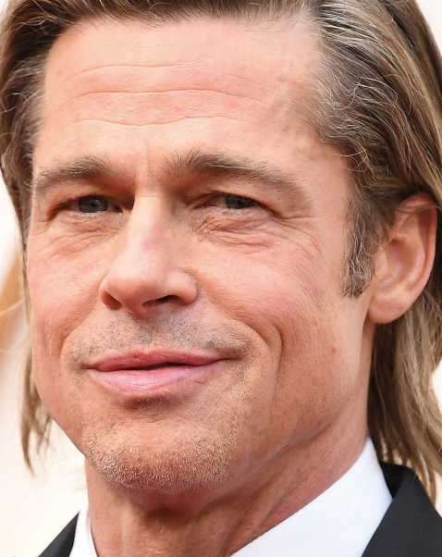

**2.1: Spatial Domain:** [2 points] Select a Gaussian smoothing filter with the two parameters of variance and kernel size of your choice. You can experiment with the two parameters to get a result to your satisfaction. Filter the given image with this Gaussian kernel.

**Tip:** Since the given image is of high resolution and in RGB space, you will have to choose the kernel size and variance appropriately.

Mention in report the kernel size and variance. Include the resulting smoothed ***colour*** image.

**2.2: Frequency Domain Low-Pass Filter** [1.5 points]**:** Now you will do the same smoothing in the frequency domain. The Discrete Fourier Transform of a Gaussian kernel turns out to be, in fact, a low pass filter. First of all, calculate the 2D FFT of the Gaussian filter you have just used in Step 2.1 and plot is so that the zero frequency component is at the centre of the plot.

Include the zero-centered FFT plot in your report.

***Tip:***  You can refer to the examples provided in Lab Exercises 1 to calculate 2D FFT and plot it in OpenCV.

**2.3: Frequency Domain filtering** [4 points]**:** Next, you will filter the celebrity image with a low-pass image in the frequency domain. You can either choose the filter created in the previous step or create a new low-pass filter. The goal is to get a visually smooth looking skin in the image. You will first filter the given image with the low-pass filter of your choice and then us the inverse FFT to get the filtered image back in the spatial domain. Feel free to do some trial and error with the low-pass filter to get a good-looking smooth skin.

Mention the low-pass filter type, the selected parameters and the resulting smoothed image in the spatial domain after inverse FFT in the report.

**2.4: Comparison** [1 point]**:** Include the two smoothed facial images, one obtained in step 2.1 via spatial filtering and one obtained in step 2.2 via frequency filtering, side-by-side in your report. Write a few lines of commentary on their similarities and dissimilarities. Would you prefer a specific domain, spatial/frequency, for this task?

**2.5: Unseen Image Testing** [1.5 points]**:** Now choose another test colour facial image of your choice. It can be downloaded from the Internet or from your own private album and can be of any size. Use the same low-pass filter you have used in the previous stage. Take the inverse FFT to see the filtered image in the spatial domain. What do you observe?

Include the unseen test image, resulting filtered image and a few lines of commentary in your report.

***Great! You have just completed an interesting application of digital signal processing for image enhancement.***